CSE230: Discrete Mathematics (Sec-7)

Quiz #4

Total Marks: 30 Time: 1 hour

|  |  |
| --- | --- |
| **NAME:** | **ID:** |

**Please read the instructions carefully before attempting to answer the questions. You have to write your solutions on the designated space for each question on the question paper. No extra sheet(s) will be provided.**

1. You have been called to jury duty in a town where there are two ride sharing companies, Uber Technologies Inc. and Pathao. Pathao uses cars painted blue; Uber uses Green cars. Uber dominates the market, with 85% of the cars on road providing ride sharing.

On a misty winter night a car sideswiped another car and drove off. A witness says it was a blue car.

The witness is tested under conditions like those on the night of the accident, and 80% of the time she correctly reports the color of the car that is seen. That is, regardless of whether she is shown a blue or green car in misty evening light, she gets the color right 80% of the time.

As a jury, your job is to find which event is most likely: the sideswiper car being blue or being green. What will you report?

Marks: 06

1. A tarantula is a large, fierce looking and somewhat poisonous tropical spider. Once upon a time, 3% of consignments of bananas from Honduras were found to have tarantulas on them, and 6% of the consignments from Guatemala had tarantulas.

40% of the consignments came from Honduras. 60% came from Guatemala.

A tarantula was found on a randomly selected lot of bananas. What is the probability that this lot came from Guatemala?

Marks: 05

1. In a certain game, you perform three tasks sequentially. First, you flip a coin, and if you get heads you win the game. If you get tails, then you move to the second task. The second task is rolling a single die. If you roll a six, you win the game. If you roll anything other than a six on the second task, you move to the third task: drawing a card from a full playing-card deck. If you pick a spades card you win the game, and otherwise you lose the game. What is the probability of winning?

Marks: 05

1. The incidence matrix for a graph G is given below:

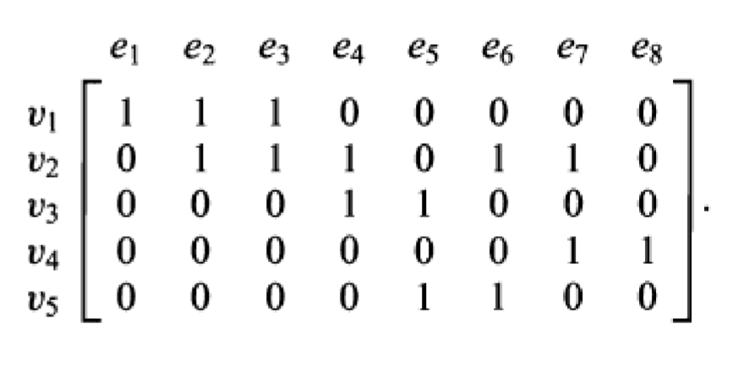

Represent G using both Adjacency List and Adjacency Matrix.

Marks: 03+03=06

1. Check whether the given graphs G and H are isomorphic or not. Then find out if G and/or H has an Euler path and/or Euler circuit or not. Explain your logic behind your answer.

Marks: 04+04=08

